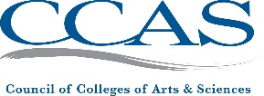 | Council of Colleges of Arts & Sciences 1935 County Road B2 W, Ste 165 | Roseville, MN 55113  Email: connect@ccas.net  Website: ccas.net

INVOICE
4/11/2023

DESCRIPTION | AMOUNT
CCAS 2023 Membership Dues – SMALL/VERY SMALL | $525.00 USD
TOTAL PAID | $00.00 USD
TOTAL DUE | $525.00 USD

Payment Options:

To pay online via credit card, please log into your account at ccas.net

To pay by mail, please send a check to the address above.

Thank you!

